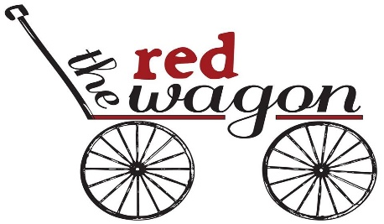

2018 Price Schedule

Birthday Parties For Ages 2 to 17 years:

- Mini Party Package, 2 hour party: Up to 4 children $125
- Sewing Party Package: 2 hour party: Up to 6 children $150
- Standard Party Package, 2 hour party: Up to 8 children $150

- Grande Party Package, 2 1/2 hour party: Up to 14 children $225
***Each party package includes ONE guided art/sewing/ or craft project of your choice and all supplies required, *unless you choose our custom party package below.

- Custom Party Package: Party time, number of guests, and project(s) vary according to prior made agreement/arrangements with Red Wagon.

Your agreed party package price will remain the same, regardless of the number of guests that arrive at your scheduled event. We can upgrade your package to include more guests with 72 hours of notice if needed.

*An instructor will guide your party while you sit back and enjoy! Our packages include: all supplies for your chosen craft or sewing project, completed project for each child to take home, supply set up, clean up after party, and use of our facility. You will have the option to choose your project upon scheduling your special event.

Facility Rental: (Not guided by an instructor)

Includes our beautiful open venue, use of our tables, chairs, lighting, music, wine glasses, mini fridge, microwave, aprons, restrooms, ample parking and a friendly inviting atmosphere.

(Birthdays parties, Friends night out, Graduations, Baby showers, Holiday parties, Special Celebrations, Office events for staff, etc.)

- 2 Hours: $125
- 3 Hours: $150
- 4 Hours: $200
- 4-6 Hours: $250
- 6-8 Hours: $300
- All day: $400
School Field Trips:
(Students will complete a hand sewn or sewing machine project & participate in a field trip to the
The Red Wagon or we can arrange to teach in your child’s classroom)
$4 per student Paradise/Magalia $5 per student Durham/Chico/Oroville

Adult Groups/Party Prices:
Canvas painting:
Group of 4-15 Adults, $35 person
Group of 16-25 Adults, $32 per person
*Traveling Canvas classes (We will come to your home or facility): $45 per person (locally only, must have a minimum of 10 students)

Wooden signs:
Group of 4-15 Adults, $30 per person
Group of 16-25 Adults, $25 per person *Traveling wood sign classes $35 per person

